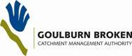

Celebrating Community NRM
in the Goulburn Broken 2013

NOMINATION FORM

for the Goulburn Broken Community NRM Awards 2013

CLOSING DATE: Wednesday 1st May, 2013
(Nominations for CMA and Landcare staff will not be accepted)
Please submit a separate entry form for each category.

Nominee
Dr Mr Miss Mrs Ms (please circle one option)
Name:
Group/Organisation:
Postal address:
Home phone number: Facsimile number:
Mobile phone number: Email address:

Nominated By (if different from above)
Is the nominee aware that you have nominated them? Yes No
Name:
Group/Organisation:
Postal address:
Home phone number: Facsimile number:
Mobile number: Email address:

Tick one box for the award category you wish to nominate for:

Community Education Award This award will be made to a primary or secondary school or youth group – either as a whole class or special group. The award is for the contribution to raising an understanding of the Landcare ethic amongst students and/or the community, and for implementing Landcare practices on their own property or within the local community.

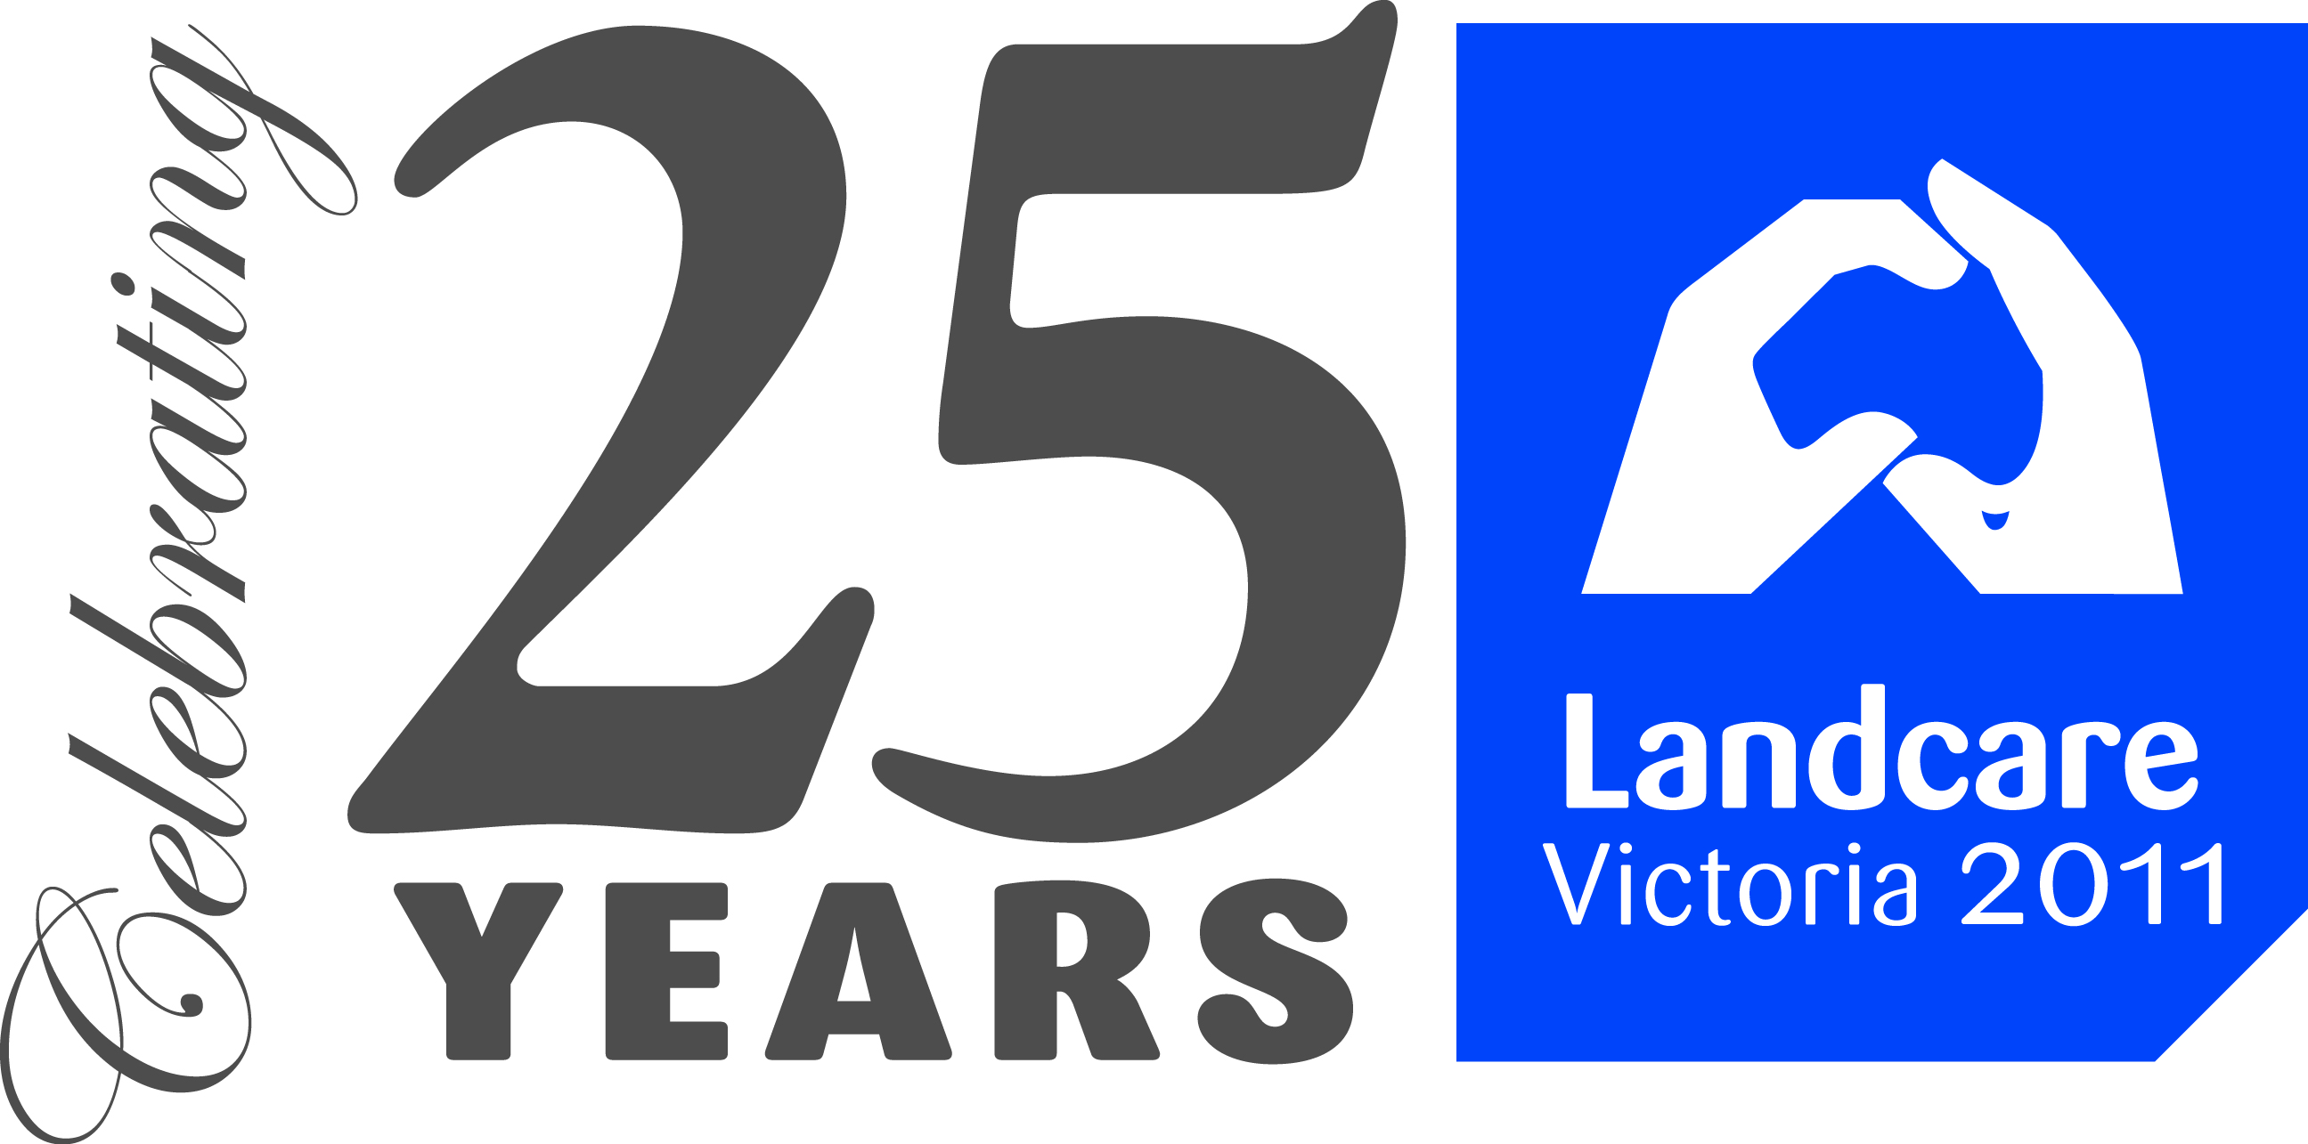
Community Sustainable Farming Award This award will be made to a primary producer or enterprise (i.e. an agricultural cooperative, network, agricultural industry association, research group, private business or primary producer) involved in primary production who implements innovative practices or activities to improve natural resource management and productivity outcomes.

Community Group Award This award will be made to an outstanding community group that has adopted best management practices on public or private land and is working towards enhancing or protecting an area on behalf of the community.

Community Network Award This award is presented to one of the region’s many Landcare or Conservation Management Networks that engage their local community and achieve significant landscape change.

Hubert Miller Perpetual Trophy This trophy was named after Hubert Miller OAM (Order of Australia Medal) a living legend in waterway and catchment management for over 50 years. This award is presented annually to an individual in the catchment who has made an outstanding contribution to engaging the community in natural resource management.
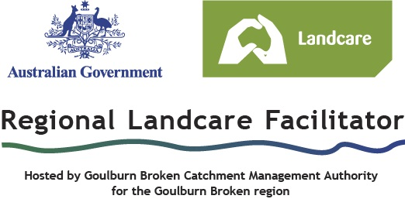
Your application should include information:

- The completed application (above) and the written part of your application is to be no more than 2 (two) A4 pages in an electronic format.

- Supporting documents including why your nomination is being submitted, relevance to the category you have chosen, length of service and, why this person / project / group stands out to you as being worthy of an award for this category.
Other attached documents can include project plans, maps, and publications, before and after photos of projects and/or media coverage for each individual entry.

- High resolution photographs applicants must submit two, good quality colour photographs featuring activities that can be used for promotional purposes. Photographs should be saved separately as JPG or TIFF files with a file size of 2-3 Megabytes per photo.

If you are having problems with the quality of photo can you please notify us in plenty of time and we can try to source a photo from other options.

With your approval, if you are a successful Goulburn Broken Community NRM Award category winner we will pass on your nomination to the Victorian Landcare Awards held later in 2013.

Where to send your nomination  GB Community NRM Awards –  Karen Brisbane  PO Box 1752, Shepparton 3632  Phone: 5832 1133  Email: Karenb@gbcma.vic.gov.au | For further information or copies of this form contact your local Landcare coordinator.

We look forward to receiving your nomination for the
Goulburn Broken Community NRM Awards 2013
☺

