
li

Floodplain Management Principles and
Best Practice Assessment for
Land Use and Development

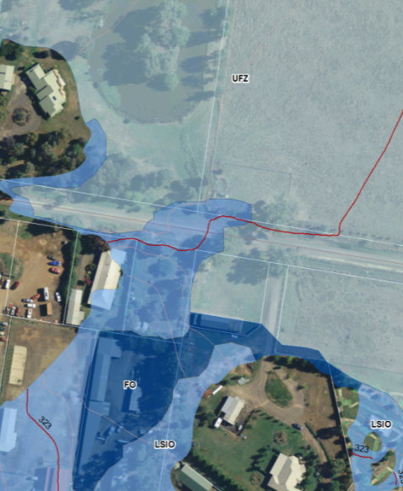
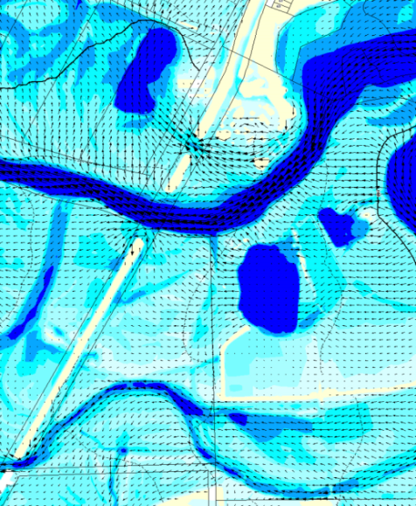

July 2014

Goulburn Broken Catchment Management Authority
168 Welsford Street
PO Box 1752
Shepparton, VIC 3632
T: 03 5822 7700
F: 03 5831 6254
E: info@gbcma.vic.gov.au
www.gbcma.vic.gov.au

Images on the front cover:
Left: Sample overlay mapping in a council planning scheme
Right: Sample of flow depth and velocity vectors

DOCUMENT CONTROL
Revision History
Version | Date | Author | Modifications
v01 | 08/07/2014 | Guy Tierney | First draft released for review at workshop with Camille White (NC), Shaun Morgan (NC), Tim Loffler (NE), Dean Judd (GB) and Guy Tierney (GB) on 15 July 2014. Also broad input by Michael Edwards (DEPI)
v02 | 18/07/2014 | Guy Tierney | Restructured, additional background, and new sections added and updated glossary. Next release following testing over the next six months of use. Action to include two new appendices: standard conditions, and guidelines for hydraulic consultants
V03 | 21/05/2014 | Guy Tierney | Clarify Greenfield Section
V03 | 07/072020 | Guy Tierney | Keep reference to GB CMA forits website

Table of Contents
Glossary iv
1. Structure of this document 1
1.1 Purpose and users of this document 1
1.2 Why is this document needed? 2
1.3 CMA floodplain management functions and statement of obligations 2
1.4 How is floodplain management advice provided? 3
1.4.1 Duties of a referral authority under the Planning and Environment Act 1987 4
1.5 CMA statutory response timeframes 4
1.5.1 Response timeframes under the Planning and Environment Act 1987 4
1.5.2 Non-Statutory Timeframes 6
2. Sources of flood information 7
2.1 General 7
2.2 The adopted statewide flood standard for planning 7
2.3 Available 1% AEP flood extent mapping 7
2.3.1 General 7
2.3.2 Planning schemes 7
2.3.3 Victorian flood database 8
2.3.4 Australian flood studies database 8
2.3.5 Other Sources 8
2.4 Available 1% AEP flood height mapping 8
2.5 Making initial contact with the CMA 8
3. General 9
3.1 Floodplain management objectives 9
3.2 Floodplain principles 9
3.2.1 Intensification 9
3.2.2 Preserving flood storage and flow conveyance 9
3.2.3 Site and accessway safety 9
3.2.4 Cumulative impacts 9
3.2.5 Minimising flood risk for new buildings 9
3.2.6 Emergency and community facilities 10
3.2.7 Protection of environmental values and water quality 10
4. General 11
4.1 Exemptions 11
4.2 Intensification 11
4.2.1 High energy floodplain areas not to be intensified 12
4.2.2 General floodplain areas not to be intensified 12
4.2.3 Intensifying the impacts of flooding by new levees 12
4.3 Preserving flood storage and flow conveyance 13
4.4 Site safety and accessway assessment 16
4.5 Minimising flood risk for new buildings 18
4.6 Emergency and community facilities 20
4.7 Protection of environmental values and waterway quality 20
4.8 Reference material 21
5. Application assessment 23
5.1 Lodging of applications 23
5.2 Workflow and application assessment 24
5.3 Verbal enquiries (telephone and counter enquiries) 24
APPENDIX A: Statutory referral types, time frames, response options, restrictions and application register 27
APPENDIX B: Exemption from floodplain management conditions 30
APPENDIX C: Information to be provided by the applicant 31
APPENDIX D: Decision guidelines and fundamental principles checklist 33

List of Figures
Figure 1-1: Timeframes for referral and responsible authorities under the Planning and Environment Act 1987 5
Figure 5-1: Flood controls and requirements contained in council planning schemes 25
Figure 5-2: Floodplain requirements where planning schemes do contained flood overlays or floodway zones 26

List of Tables
Table 1-1: Statutory referrals 3
Table 4-1: Afflux limits 15
Table 4-2: Extension limits to existing dwellings 20
Table 5-1: CMA contact details for lodgement of applications 23

Glossary
100-year ARI See 1% AEP Flood
1% AEP flood The 1% chance (likelihood) of a flood of a certain magnitude will be equalled or exceeded in any year. This has the same meaning as the 100-year Average Recurrence Interval (ARI) flood (See ARI). This is the adopted standard on which is used to assess land use and development.
AEP Annual Exceedance Probability – is the likelihood of occurrence of a flood of given size or larger occurring in any one year. AEP is expressed as a percentage (%) and may be expressed as the reciprocal of ARI (Average Recurrence Interval).
ARI Average Recurrence Interval - is the likelihood of occurrence, expressed in terms of the long-term average number of years, between flood events as large as or larger than the design flood event. For example, a flood with a given size or larger than the 100-year ARI flood, will occur on average once every 100-years.
Accessway a trafficable link provided by a public and/or private road between a development within a floodplain and to land outside the 1% AEP flood extent of a particular floodplain system.
CMA Goulburn Broken Catchment Management Authority
Development Includes a building, work or subdivision. This is further defined in detail under the Planning and Environment Act 1987.
Flood hazard Flooding over land and floodplains that can be defined by flood characteristics in terms of the product of flood depth by velocity. Such land and floodplains has the potential for flood risk where inappropriate uses and developments occur.
Flood Risk Can be defined by linking the likelihood of a flood (AEP) to its consequences (e.g., flood damage and human suffering). In other words, there is a likelihood of a flood, expressed in terms of a particularly AEP that will reach a particular flood extent and height, which in turn, may adversely impact on existing communities and developments.
Flooding Riverine (Mainstream) Flooding: Occurs when runoff from a catchment into a waterway becomes overwhelmed and burst their banks flooding adjoining floodplains which are usually not under water.
Urban (Overland Flow Paths) Flooding: Occurs when rainfall exceeds the capacity of soil profile or the stormwater system that results in water flowing overland. For further reading see Flood Types on the Flood Victoria website.
Freeboard Height (or distance) between the flood level (usually the 1% AEP flood) and the building floor level or top a structure (such as a levee). It is an allowance to ensure that protection against a flood which is expected to occur while taking into account uncertainty and wave action.
LFDP Local Floodplain Development Plan sets out performance-based criteria for development that is an incorporated document in a planning scheme.
LSIO Land Subject to Inundation Overlay, as shown in planning schemes.
m AHD metres Australia Height Data (m AHD), is the adopted national height datum that generally relates to height above mean sea level. Elevation is in metres
NFPL Nominal Flood Protection Level – the level above the 1% AEP (100-year ARI) flood level that includes appropriate freeboard.
Responsible Authority A statutory authority that administers a planning scheme under the provision of the Planning and Environment Act 1987, usually by the local council. Note that other authorities administer statutory approvals under range of Acts.
Referral Authority Listed in Clause 66 of council planning schemes where the responsible authority must refer a copy of a planning permit application to the specified referral authority (referral authority under the Planning and Environment Act 1987). CMAs are known as the floodplain management authority in planning schemes. Note the CMA also acts as a referral authority for matters other than through planning schemes.
RFO or FO Rural Floodway Overlay or Floodway Overlay, as shown in planning schemes.
VFD Victorian Flood Database – central flood data held and managed by the Department of Primary Industries and Environment.
VPP Victoria Planning Provisions (suite of standard provisions, zones and overlays used to prepare planning schemes in Victoria).

CHAPTER 1 – General Background

Structure of this document
Chapter 1 – General Background
Provides information on what the CMA does including its functions and obligations. Details application types and CMA contact and application lodgement details

Chapter 2 – Access to Flood Information
Provides guidance on how to seek available flood information to assist with the preparation of the application (self-help if desired) and CMA assessment

Chapter 3 – Flood Objectives and Principles
Provides the overriding objectives and principles, particularly where best practice performance-based principles are silent for a particular matter

Chapter 4 – Best Practice Performance-Based Criteria
Provides specific performance-based criteria upon which to assess particular developments and rezoning applications

Chapter 5 – Application Assessment
Provides guidance for self-assessment and matters that the CMA take into account when deciding and responding to an application for flood advice

Purpose and users of this document
The purpose of this document, Floodplain Management Principles and Best Practice Assessment for Land Use and Development, within the CMA catchment, is to articulate and set out:
- CMA functions, obligations and its broad objectives and principles in floodplain management, focussed particularly on land use and development planning;
- Best practice performance-based criteria which are used to ensure consistent decision-making is carried out across the three Catchment Management Authorities. This includes specific performance-based criteria for the most common type of applications that will assist: developers and landowners in preparing their applications (if desired), and the CMA in its assessment and response; and
- CMA procedures and processes including how it assesses and responds to applications, including timeframes.

The users of this document include practitioners in floodplain management, land use planners, and applicants wishing to develop land within floodplain areas as defined by the estimated 1% AEP flood extent.

Why is this document needed?
Many communities, which have settled within floodplains, are today exposed to hazard in times of major flood. Significant consequences are a reality, in terms of both flood damage and human suffering, as a result of unplanned development within floodplains. This is known as the existing (or legacy) flood problem.
Statutory land use and development planning is a way to manage the exposure to future flood risk by not unduly adding to the legacy flood problems.
Land capability assessment, in terms of managing future flood risk through land use planning and development controls, seeks to:
- Steer inappropriate land uses and developments away from floodplain areas.
- Minimise the exposure of new developments to flood hazard, including intensification
- Minimise adverse impacts on existing settled areas from new development and intensification.
- Preserve flow conveyance and temporary flood storage so they are not unduly compromised.
- Minimise the demands on emergency and community services.
- Protect environmental values and water quality within floodplain and waterway areas.
Flood hazard on floodplains largely becomes an issue when they are inappropriately developed thus creating exposure to flood threat. The flood risk is a term used to link the likelihood of a flood to its consequences.

CMA floodplain management functions and statement of obligations
Floodplain management functions have been delegated to the CMAs, and are described under Section 202 of the Water Act 1989. A specific function is to provide advice about flooding and controls on development to local councils, the Secretary to the Department and the community.
In 2006, the Minister for Water issued The Statement of Obligations under the Water Act 1989, which relate to the existing functions and responsibilities of the CMA under the Act as well as associated Government policy. The CMA has the following obligations with respect to floodplain and waterway statutory planning:
- Provide advice about flooding and controls on planning scheme amendments, and planning and building approvals to local councils in its capacity as a referral body in accordance with relevant legislation.
- Provide advice to rural and urban water authorities, local government and State Government agencies on aspects of their business, or matters which they are handling, which impact on river health.
- Provide advice on planning referrals which relate to waterway, water quality and any other river health issues when requested by local government.
- As a referral body for any:
- application for a licence to construct works; and
- application for a licence to take and use water.
- Provide advice in respect of a dam in accordance with relevant legislation.
- Advise the Department on conditions for licences in respect of Crown frontages.
From these obligations, it is clear that waterway and floodplain management are interrelated matters that need to be assessed for any application for land use and development.

How is floodplain management advice provided?
The CMA, as a referral authority, provides floodplain management advice to a number of statutory authorities under of number of Acts, as outlined in Table 1-1.
Table 1-1: Statutory referrals
Agencies | Act | Statutory Referral Type
Local Councils | Planning and Environment Act, 1987 | Planning permit applications for land use and development  Planning Scheme Amendment applications
 | Subdivision Act, 1987 | Certification and Statement of Compliance usually if referred under Section 55 of the Planning and Environment Act 1989
 | Building Regulations, 2004 | Consent for a building height or relaxation thereof. Not necessary if dealt with under the Planning and Environment 1989 through a council issuing of a planning permit.
Rural Water Authorities | Water Act, 1989 | Take and Use and Dams
Department of State Development, Business and Innovation | Minerals and Resources (Sustainable Development) Act, 1990 | Mining and quarrying
Environment Protection Agency | Environment Protection Act, 1970 | Work Authority and licences
Department of Environment and Primary Industries | Land Act, 1956 | May informally request advice relating to Crown land.

Table A contained in Appendix A, details the relevant sections of the Acts that provide for statutory referrals, available response options, and the required timeframes.
In addition, to referrals from statutory authorities, any person (including authorities outside the statutory processes) can apply for flood advice or flood information directly from the CMA as outlined in Chapter 5.
On occasions, councils have recommended to applicants to seek flood advice from the CMA before submitting a planning permit with council. Where a planning permit application is lodged with council together with CMA written advice that is less than 90 days old, council is not required to refer the application back to the CMA unless there are substantial changes.
Where councils have no flood controls in the planning scheme, the council’s planning department may give notice under the Planning and Environment Act 1987 if it suspects flooding to be an issue of concern. Similarly council’s building department can seek advice and consent under the Building Regulations 2004.
The bulk of applications received by the CMA are from local councils as statutory referrals. Therefore, this document pays particular attention to referral processes under the provisions of the Planning and Environment Act 1987.
Under Clause 66 of the Victoria Planning Provisions (upon which all council planning schemes are prepared), the CMA is listed as the floodplain management authority under the heading of referral authority for permit applications contained within either the Land Subject to Inundation Overlay (LSIO), Floodway Overlay (FO) or Urban Floodway Zone (UFZ). Furthermore, under the heading type of referral authority, the CMA is a listed as a recommending authority and not a determining authority. This means the CMA referral response advice given to councils will be considered by council but is not mandatory e.g., the setting of conditions by CMA are recommendations.
In addition, the CMA provides advice on planning scheme amendments including the rezoning of land.

Duties of a referral authority under the Planning and Environment Act 1987
Section 14A of the Planning and Environment Act 1987, sets out the duties of a referral authority. A referral authority must:
- Have regard to the objectives of planning in Victoria in considering the matter;
- Have regard to the Minister for Planning’s directions;
- Comply with the Planning and Environment Act;
- Have regard to the planning scheme; and
- Provide information and reports as required by the Minister.

CMA statutory response timeframes

Response timeframes under the Planning and Environment Act 1987
The CMA is committed in meeting the various statutory timeframes as contained in Appendix A. The bulk of the applications are received from local Councils under the Planning and Environment Act 1987. Therefore, this is the prime focus for this document. The timeframes under this Act are shown diagrammatically in more detail in Figure 1-1.

DAY 1
APPLICATION RECEIVED BY COUNCIL
Should be referred to Referral Authorities without delay
[Sec 55 (1)]

CMA TIMEFRAME
APPLICATION RECEIVED BY REFERRAL AUTHORITY
Unless previously responded in writing within last 3 months
[Sec 55(1) (a), (b) & 2]
DAY 1

TIMEFRAME

LAST DAY WHEN MORE INFORMATION MAY BE REQUESTED BY REFERRAL AUTHORITY
Day 21 after referral authority receives application
[Sec 55(2)]
DAY 21

DAY 28

REFERRAL AUTHORITY RESPONSE RECEIVED BY COUNCIL
Response may be:
a) no objection; or
b) no objection with conditions; or
c) objection with grounds.
Day 28 after referral authority receives application [Sec 56]

COUNCIL MUST MAKE A DECISION ON APPLICATION (NOTICE OF DECISION)
Decision may be –
a) grant a permit (with or without conditions); or
b) refuse to grant a permit ; or
c) notice of decision to grant a permit (if objections received).
Otherwise an appeal may be made [Sec 59]
DAY 60

COUNCIL

APPLICANT MAY WISH TO APPEAL NOTICE OF DECISION BY COUNCIL
- If permit is issued with conditions, applicant has 60 days from date of issue to lodge an appeal against the validity of a condition [sec 77].
- If permit is refused, applicant has 60 days to lodge an appeal against refusal [sec 80].

DAY 120

Figure 1-1: Timeframes for referral and responsible authorities under the Planning and Environment Act 1987

Non-Statutory Timeframes
Where sufficient information has been submitted for non-statutory enquiries, such as flood information requests (e.g., insurance advice, advice for Section 32 Sale of Land Statements, or just of flood data), and flood advice on proposed developments or planning scheme amendments (e.g., feasibility advice), the CMA will endeavour to respond within 21 days.

CHAPTER 2 – Access Flood Information

Sources of flood information

General
Whether an application is within an identified floodplain will determine the need to seek a planning permit from council or to seek CMA flood advice. This section provides how to seek flood information, which is largely in the public domain.

The adopted statewide flood standard for planning
The 1% Annual Exceedance Probability (AEP) flood – also known as the 100-year Average Recurrence Interval (ARI) flood – has been adopted as the standard for flood mapping (e.g., 1% AEP flood extend, height and velocity), and for assessments for land use and development applications.

Available 1% AEP flood extent mapping

General
There is a variety of flood mapping, which is publically available. The CMA may assist with confirming, or otherwise, the relevant flood mapping to be used for planning and assessment.
It is important to note that flood information is not always available or identified for all areas. As such, there are properties within floodplains or adjacent to waterways or overland flow paths that may be subject to flood inundation. The CMA may be in a position to assist in how to determine if a site is likely to be flood prone in a 1% AEP flood.

Planning schemes
Planning schemes across Victoria have been prepared using the Victoria Planning Provisions that provide a standard suite of zones and overlays, state and local planning policy frameworks, general provisions and decision guidelines (for further information go to planning schemes online).
The applicable zone and overlay controls used for floodplain management are the Urban Floodway Zone (UFZ), Flood Overlay (FO) and Land Subject to Inundation Overlay (LSIO). Some councils have included this information into their respective planning schemes. Eventually, all applicable flood mapping will be contained within all planning schemes across Victoria.

Victorian flood database
The Victorian Flood Database (VFD) is the State’s central repository of flood related information, and should be consistent with flood mapping contained within planning schemes. The VFD is managed by DEPI with information generated or collected by the respective CMAs.
Therefore, in the absence of council planning schemes having flood zone and overlay controls, the VFD is the key source of determining whether a property is subject to flooding. 1% AEP flood mapping (known as the 1 in 100yr flood and Floodways) is freely available online by selecting the relevant tick box on the Victorian Water Resources interactive map.

Australian flood studies database
The Australian Flood Studies Database is a central repository of flood study reports across Australia, which may include flood mapping – refer to Geoscience Australia website.
Note such flood mapping information is largely used to prepare planning scheme overlays and the information contained in VFD.

Other Sources
Other sources of flood mapping could be created internally by the CMA from in-house mapping and flood studies that is yet to be placed into the planning scheme and VFD.

Available 1% AEP flood height mapping
Flood height (or level) information is usually displayed as flood height contours generally at 0.2m intervals to metres Australia Height Datum (m AHD), which is height in metres above mean sea level.
Flood level contours that have been declared or designated under the Act are publically available free of charge during business hour at the CMA Office. This information is also available from the CMA website or from the VFD. The latter will require a request for information from the Department of Environment and Primary Industries (DEPI).

Making initial contact with the CMA
Enquirers may contact the CMA directly to obtain general advice before lodging an application for flood advice or flood information with the CMA, or lodging a planning permit application with council.
Councils have encouraged applicants to obtain written advice from the CMA prior to lodging and application for a planning permit.
Chapter 5 provides how to contact the relevant CMA and how to lodge an application.

CHAPTER 3 – Floodplain Objectives and Principles

General
This section provides an overview of floodplain objectives and principles, which links to Chapter 4: Best practice – performance based criteria for the comment types of land use and development applications. Where such performance-based criteria are silent (absent) on a particular matter then this Chapter plays a significant role in decision making.

Floodplain management objectives
The broad floodplain management objectives used in land use planning are described in the State Planning Policy Framework (Victoria Planning Provisions), which are contained in all planning schemes at Clause 13.02-1, and which the CMA adopts as policy:
Floodplain management objective is to assist the protection of:
- Life, property and community infrastructure from flood hazard.
- The natural flood carrying capacity of rivers, streams and floodways.
- The flood storage function of floodplains and waterways.
- Floodplain areas of environmental significance.
All land use and development applications must be consistent with the above objectives.

Floodplain principles
Where relevant, land use and development applications must be consistent with the following principles:

Intensification
Avoid intensifying the impacts of flooding through inappropriately located uses and developments.

Preserving flood storage and flow conveyance
The temporary storage of floodwater and flow conveyance must not be unduly compromised by inappropriate uses and developments.

Site and accessway safety
Uses (rezoning to urban land uses) or developments (dwellings) sited on low-lying land or has to rely on low level accessways should be avoided.

Cumulative impacts
The cumulative impact of inappropriate uses and developments including floodplain encroachments should be avoided. In principle, inappropriate uses and developments, including floodplain encroachments, should not be approved if they present an undesirable precedent.

Minimising flood risk for new buildings
Freeboard must be applied in accordance with the Building Regulations 2004, VPP Practice Notes, and any planning permit condition.

Emergency and community facilities
Locate emergency and community facilities outside the 1% AEP floodplain and, where possible, at levels above the height of the probable maximum flood.

Protection of environmental values and water quality
The environmental values of floodplains, waterways, wetlands, and riparian environs must be protected or enhanced. Developments and uses:
- Must not unduly compromise water quality in receiving waterways and wetlands.
- Which involve the storage and disposal of environmentally hazardous industrial and agricultural chemicals or wastes and other dangerous goods (including intensive animal industries and sewage treatment plants) should be avoided.

CHAPTER 4: Best Practice – Performance-Based Criteria

General
This Chapter provides performance-based criteria upon which land capability assessment for rezoning and development is carried out, for the most common land use and development applications.
The setting of performance-based criteria is a way to measure if an application meets acceptable limits to manage future flood risks.
This Chapter provides both descriptive best practice guidelines and particular performance-based criteria setting limits for the following flood attributes:
- Flood extents.
- Flood heights (levels).
- Flood velocity.
- Flood depth.
- Flood hazard (the product of velocity by depth).
The above attributes and limits quoted in this Chapter are for the 1% AEP flood.
Although the above flood attributes are the main drivers of land use and development assessment, flood frequency and duration are matters taken into account where they present a significant concern.

Exemptions
There are many developments (building and works) that are exempt from the need for a planning permit from council. Exemptions exist within some council planning schemes in the Schedules to the Floodway Overlay (FO) or Land Subject to Inundation Overlay (LSIO). These can be found on planning schemes online.
In addition, Appendix B lists the most common development exemptions for which assessment against performance-based criteria is not required. In other words, the CMA would approve such developments. Note however that if no exemptions exist in the planning scheme, then Council must refer applications to the CMA for its assessment and response.

Intensification
Avoid intensifying the impacts of flooding through inappropriately located uses and developments.
This seeks to steer rezoning and development away from areas where it may adversely impact on:
- The nature of flooding (flood conveyance and storage);
- Adjoining infrastructure and existing communities;
- Environmental values including waterways, wetlands, riparian areas, and water quality; and
- Additional demands on emergency and community services.

High energy floodplain areas not to be intensified
Land use rezoning, buildings or works are not to intensify floodplain areas that can be categorised by the CMA with the following attributes:
- Floodplains are relatively:
- Narrow;
- Steep; and
- Confined by a terrace or valley wall.
- These are high energy floodplains where intensification will create adverse impacts as described above in Section 4.2.
For example, rivers and floodplains located on the slopes of the Great Diving Range are typically confined and fast flowing during times of major floods. Such areas are generally deep or are high hazard areas.
Land use rezoning and development are to be located outside the 1% AEP high energy floodplain areas. The exception to this will be the consideration of public good (such as regional road and rail connections) and works that advance environmental outcomes (such as to enhance wetland watering by the use of low-levee earthen bunds) provided they meet the afflux limits and other general requirements set out in Section 4.3.2.

General floodplain areas not to be intensified
This section is in addition to Section 4.2.1 above, where the floodplains are not considered as high energy streams (or high hazard) but where intensification may be compatible with the flood hazard.
This largely relates to new areas being developed known as greenfield sites. Typical, rezoning of farming land to allow residential use and development could potentially lead to adverse impacts as outlined in Section 4.2 and unduly add legacy flood problems. Consideration of greenfield sites is outlined in Section 4.3 preservation of flood storage and flow conveyance.

Intensifying the impacts of flooding by new levees
No new levees will be supported unless:
- Levees have been considered as part of an approved scheme process under the Water Act 1989 (or under the Local Government Act 1990);
- Levees are limited to protecting the immediate surrounds of existing habitable dwellings within a rural zone:
- where the floor level is below the 1% AEP flood level; and
- not enclose an area of more than 1000m² including the footprint area of works provided no neighbouring buildings are likely to be adversely affected.
- Larger footprints areas may be considered but would be subject to detailed assessment and possibly including adverse impact assessment using hydraulic modelling.
- Low levees (small bunds) are proposed that may advance significant environmental outcomes, e.g., assist with watering wetland environments for waterbird breeding.

Preserving flood storage and flow conveyance
Any alteration to the temporary storage of floodwater or flow conveyance (flood carrying and storage function of the floodplain) must not create adverse impacts as outlined in Section 4.2.
Floodplains along riverine systems may contain a range of physical features such the bed and banks of the waterway, multiple terraces, alluvial ridges, valley walls, depressions and anabranch systems (prior streams).
In contrast overland flow paths through urban centres are generally confined and narrow where any interference is likely to cause adverse impacts to neighbouring properties and buildings.
The interference of natural features and overland flow paths should be avoided.

Greenfield sites
Encroachment into floodplain areas through rezoning and development of greenfield sites needs to be assessed for their land capability as follows:
- The extent of development in greenfield sites is to be limited to 0.3 metres below the relevant 1% AEP flood level. Detailed hydraulic modelling by a suitably qualified hydraulic consultant may be required by the CMA to clearly demonstrate no adverse impacts on surrounding areas. Areas up to a maximum depth of 0.5 metres may be considered subject to detailed hydraulic modelling as defined above and noting:
- Greenfield sites within floodplain areas earmarked for rezoning to residential zone are usually filled. Other rezoning (e.g., low density residential or industrial zones) may only require filling of the building envelopes. Note residential zones including low density residential cases, site safety must be assessed as described in Section 4.4.
- Compensation for the loss flood storage must meet the requirements of (b) below.
- Residential lots are to be filled in accordance with the Infrastructure Design Manual (IDM), e.g., building envelops filled to the 1% AEP flood level.
- Natural overland flow paths and natural floodplain features should be retained in principle. If an applicant seeks to modify such flow paths and floodplain areas, then compensatory earthworks must be designed to compensate any loss of flood storage by a factor of 1.3. In other words, the volume of cut shall exceed the fill by 30%. Excavations to deliver this storage must:
- Be self-draining.
- Be within the development site.
- Provide for the equivalent hydraulic capacity.
- Be compliant to any CMA conditions. The statement of compliance, under the Subdivision Act 1988, will only be considered from applicant’s plans showing ground levels (to metres AHD) of all fill and borrow areas, as constructed depths of cut and fill, and as constructed calculations showing that the net cut and fill meets the flood storage factor of 1.3 in areas at or below the applicable 1% AEP flood level.
- The avoidance principle must be considered particularly in relation to environmental protection; if applicable refer to Section 4.7.

Consideration for Afflux limits
The term afflux is used to denote the maximum increase in flood heights caused by development within a floodplain compared with flooding under natural conditions (i.e., prior to any development placed onto the floodplain) for a design event, usually the 1% AEP flood. Afflux will generally occur through encroachment into floodplains by:
- Greenfield development (intensification) from inappropriate uses and developments
- Rail and road infrastructure;
- Irrigation infrastructure;
- Levees; and
- Waterway crossings comprising bridges or culverts etc., abutments and bridge piers, and roadways/accessways across floodplain areas connecting to waterway crossings.
The design of waterway crossings or any other floodplain infrastructure must ensure no adverse impacts are created in accordance with Section 4.2. In addition, increased flood impacts across the property boundary should be avoided or minimised to an acceptable level.
Where the CMA has identified a concern in relation to potential adverse impacts by the proposed intensification or infrastructure within floodplain areas, then hydraulic computations will be required to be carried out by a suitably qualified hydraulic consultant to ensure that the more onerous of the two following hydraulic performance-based criteria is meet as follows:
- There is no increase in the flood risk to existing residential, commercial or industrial buildings, significant private or public assets, or critical infrastructure. In such cases any afflux may not be acceptable, particularly if above floor flooding is likely.
- Does not create an afflux that exceeds the following limits based on a range of flood profile gradients: as shown in Table 4-2.

Table 4-2: Afflux limits
Longitudinal gradient of flood profile over reach affected by works (prior to construction of works)# | Afflux limits depending on location of works | Afflux limits within urban areas
Flatter than 1 in 2,000 | 50-150mm | No adverse impact as described above
Between 1 in 2,000 and 1 in 200 | 100-250mm | No adverse impact as described above
Steeper than 1 in 200 | 200-300mm | No adverse impact as described above
# Notes:
    - For replacement of existing works, afflux should be considered relative to natural conditions.
    - The upper afflux limits would only be considered within essentially rural areas with no identified infrastructure.
    - Adverse impacts to existing dwellings must be mitigated to achieve zero afflux or negligible afflux. A rarer flood may be required to be assessed up to the 0.2% AEP flood.
    - Section 4.2.1 dictates that land use rezoning and development be located outside high energy 1% AEP floodplain areas
    - CMA is to apply judgement on the acceptable afflux depending on the adjacent existing infrastructure within the floodplain.

Non-greenfield sites
Any new development must ensure that flow paths are not diverted or constricted. This could occur if development is undertaken too close to a waterway or where full development of the site is proposed with no allowance for overland flows.
In these situations, a simple hydraulic calculation can be undertaken by the CMA if it has sufficient information available. However, in more complex situations or for large development sites, the applicant will be requested to provide engineering plans and computations that demonstrate that the development has no adverse impact on neighbouring properties.

Building alignment limits and associated filling
Where it can be demonstrated that proposed buildings meet the best practice performance-based criteria of this document, to further minimise the potential to restrict flood passage, new or replacement buildings:
- Must be aligned with their longest axis parallel to the direction of floodwater flow unless it can be demonstrated that this cannot be practically achieved and/or the floodplain management authority has advised in writing that an alternative alignment is acceptable; and
- Earthen fill pads used at the site of new buildings are to be no more than two (2) metres beyond the building footprint. However, in rural areas, an additional 1,000m² of filling may be considered to provide refuge for car parking and domestic shedding if filling is aligned with the direction of flow and no neighbouring buildings are likely to be adversely affected.

Piers and stilts
The use of piers and stilts for dwellings are not supported.

Site safety and accessway assessment
New buildings are to be sited on flood-free land or on the highest available land and the following relevant performance-based criteria are to be met for new dwellings and rezoning (to allow multi-lot subdivisions).
Where flood hazard information is available, it will be used as part of site safety and accessway assessment. Hazard is defined as the flow velocity by depth where development is limited by 0.35m²/s. This is generally applicable for steep floodplain and overland flow path areas.
Elsewhere, the limiting factor is based on flood depths limits as outlined in the following sub-sections.
Flood duration and frequency may be considered if they pose significant concern.

New dwellings and subdivisions within greenfield sites
Notwithstanding Section 4.2.1 new dwellings (excluding replacement dwellings) must be sited on land where the 1% AEP flood depth is less than 300mm above the natural surface level, and have an accessway from the dwelling to outside the floodplain that has a 1% AEP flood depth of no more than 300mm.
Refer to Section 4.4.4, which set out subdivision requirements.

New dwellings and subdivisions within existing urban centres
New dwellings (excluding replacement dwellings) must be sited on land where the 1% AEP flood depth is less than 500mm above the natural surface level, and have an accessway from the dwelling to outside the floodplain that has a 1% AEP flood depth of no more than 500mm.
Subdivision applications for land that is either partly or wholly within the floodplain areas, must not create new lots, unless it can be demonstrated for a 1% AEP flood that:
- There is an adequate building envelope on each lot (which must be formally defined on the plan of subdivision) where the inundation depth is determined to be less than 500mm.
- Accessway from the building envelopes to outside the floodplain is no more than 500mm.

New dwellings within an existing urban centre
A single dwelling on a single vacant lot is permitted if:
- It is immediately surrounded by existing buildings (other than sheds) on at least three sides, to the satisfaction of the CMA.
- The depth over the site and accessway is no more than one (1) metre.
- The hazard over the site no more than 0.6m²/s

New rezoning and subdivision for new urban growth areas
Rezoning of land for residential, retail, commercial or industrial purposes must meet the performance-based criteria as set out under:
- Section 4.2.1: High energy floodplain areas not to be intensified;
- Section 4.3: Preservation of flood storage and flow conveyance; and
- Section 4.7: Protection of environment and water quality.
These criteria will ensure that land capability is adequately tested for rezoning and subsequent multi-lot subdivision will provide safe accessways and building sites that would be exposed to no or acceptable flood hazard.
Subdivision applications for land that is either partly or wholly within the floodplain areas, must not create new lots, unless it can be demonstrated for a 1% AEP flood that:
- There is an adequate building envelope on each lot (which must be formally defined on the plan of subdivision) where the inundation depth is determined to be less than 300mm.
- The subdivision, to allow dwellings and associated development, is to meet the environmental and water quality requirements set out in Section 4.7.
- Accessway from the building envelopes to outside the floodplain is no more than 300mm

New dwellings within rural farming areas
Notwithstanding Section 4.2.1 new dwellings (excluding replacement dwellings) must be sited on land where the 1% AEP flood depth is less than 500mm above the natural surface level, and have an accessway from the dwelling to outside the floodplain that has a 1% AEP flood depth no more than 800mm, unless the lot is, or can be created to be no less than 80 hectares in size.
In addition, the dwelling and associated development, is to meet the environmental and water quality requirements set out in Section 4.7. In particular, to ensure there is adequate building envelop that is consistent with the Guidelines for the Protection of Water Quality (NEPRC, 2001).
Subdivision applications for land that is either partly or wholly within floodplain areas, must not create new lots, unless it can be demonstrated for a 1% AEP flood that:
- There is an adequate building envelope on each lot (which must be formally defined on the plan of subdivision) where the inundation depth is determined to be less than 500mm.
- The subdivision, to allow dwellings and associated development, is to meet the environmental and water quality requirements set out in Section 4.7. In particular, to ensure there is an adequate building envelop on each lot that is consistent with the Guidelines for the Protection of Water Quality (NEPRC, 2001).
- Accessway from the building envelopes to outside the floodplain is no more than 500mm

Minimising flood risk for new buildings
Freeboard above the 1% AEP flood level must be applied in accordance with Building Regulations 2004, VPP Practice Notes, and any planning permit condition. The 1% AEP flood level plus freeboard is known as the Nominal Flood Protection Level (NFPL).

Water resistant materials
New or replacement dwellings or new extensions to existing dwellings must use water resistant materials up to the NFPL.

Freeboard for dwellings, emergency and community buildings
The floor level of a new dwelling must be finished at least 300mm above the 1% AEP flood level as determined by the CMA.
A higher freeboard is required where:
- Emergency and Community buildings are to be constructed within identified floodplain areas or re-constructed due to existing use rights. A minimum freeboard of 500 millimetres above the 1% AEP flood level is to be applied for any floor levels of any proposed emergency and community buildings as described in Section 4.6
- Where the critical time of concentration for a flood is less than 24 hours to a particular area under consideration, climate change is likely to increase storm intensity, which in turn, will lead to increased flood levels. The determination of future 1% AEP flood levels must include an allowance for climate change in accordance with best practice (i.e., Australian Rainfall and Runoff – Project 19). Where no allowance has been made, a minimum freeboard of 300 millimetres above the 1% AEP flood level is to be applied with a recommended freeboard of 500 millimetres for any proposed dwelling, commercial or industrial type buildings.

Freeboard for retail, office and industrial buildings
The floor level of a new industrial, retail or office building (including a replacement building), must be set at least 300 mm above the 1% AEP flood level unless the applicant can demonstrate to the responsible authority and the CMA that this requirement cannot be practically achieved. A written design response statement must accompany the application to justify a proposed floor level below the nominal flood protection level. Where relevant, the design response statement must include:
- Relationship of the proposed building floor level to the floor levels of adjoining buildings, accessways (vehicle and pedestrian) and street footpaths levels, which demonstrate transport and pedestrian access into the proposed building as impractical. Submitted survey levels must be to metres Australian Height Datum, by a licensed surveyor.
- Plans and elevation drawings of the building and surrounding areas showing maximum allowable ramping grades to meet relevant Australian Standards and Building Regulation and Codes, which achieve the highest possible floor level.
- Plans showing and specifying flood proofing arrangements up to the nominal flood protection level for retail or office buildings.
- Plans showing and specifying electrical fitting located at least to the nominal flood protection level.
- Plans showing adequate storage areas and shelving above the nominal flood protection level for the storage of valuable goods and hazardous materials.
- Plans showing placement of flood markers inside and outside of the building showing the 1% AEP flood and other historical flood levels.
- A flood response action plan which sets out procedures and actions to minimise flood damage, risk to occupants, and demands on emergency services.

Freeboard for Class 7b and Class 8 type building
Buildings used for storage, or display of goods or produce for wholesale, a laboratory, or a building in which handicraft or a process for the production, assembling altering, repairing, packing, finishing, or cleaning of goods or produce is carried on for trade, sale or gain are to be considered as either a retail, shop or industrial building. Accordingly, the floor level of such buildings must be set at least to the nominal flood protection level, unless constraints exists that may be addressed for floor level relaxation in accordance with industrial and retail buildings contained in Section 4.5.3.

Freeboard for Class 10 type buildings
The following buildings and structures do not require the floor level to be constructed above the nominal flood protection level (most are exempt in schedules within planning schemes):
- Non habitable building including:
- A private garage, carport, pergola decking and open verandah adjoining to an existing dwelling;
- a swimming pool with open style fencing;
- A domestic shed with a floor area less than 100 and 130 square metres within (R)FO or LSIO respectively and associated with an existing dwelling. A domestic shed with proposed larger floor areas must be set to the nominal flood protection level, unless constraints exists that may be addressed for floor level relaxation in accordance with industrial and retail buildings contained in Section 4.5.3.
- Where applicable:
- Adequate storage areas and shelving must be provided at least 500 millimetres above the 1% AEP flood level for the storage of hazardous materials.
- Electrical fittings should comply with any requirements of the relevant power authority and should preferably be set at least 300 millimetres above the 1% AEP flood level;
- Adequate storage areas and shelving should be provided at least 300 millimetres above the 1% AEP flood level for the storage of valuable goods.

Extension limits to existing dwellings
The CMA will initially assess the potential impacts of the proposed dwelling extension on flooding in accordance with Section 4.3 to ensure it will not unduly obstruct floodwater flow. Applicants may be asked to submitted further hydraulic computations for complex matters. To minimise the impacts on flooding the following should be considered where practicable:
- Extensions should be aligned with their longest axis parallel to the direction of floodwater flow; and/or
- In the shadow of the existing dwelling where floodwater is already restricted, e.g., the extension is located either on the upstream or downstream side of an existing dwelling.
Extensions can be singular or multiple but collectively the total floor area must not exceed the limits outlined in the Table 4-2. Extensions, not in accordance with the Table 4-2 are required to set the entire extension at least to the NFPL as determined by the floodplain management authority.
Table 4-3: Extension limits to existing dwellings
Abbreviations:
1% FL: 1% AEP (100-year ARI) Flood Level.
EFL: Existing Floor Level.
Size of dwelling extension | Calculate Level difference by using (EFL - 1% FL).  Where the calculated level difference is:
Size of dwelling extension | -300mm and lower | Less than zero  up to  -300mm | Between zero  and +300mm | Greater than  +300mm
Size of dwelling extension | Allowable extension to match existing floor level (Yes/No)
Up to 20m^{2 #} | Yes^ | Yes^ | Yes^ | Yes^
Up to 40m² * | No | Yes^ | Yes^ | Yes^
Up to 80m² * | No | No | Yes^ | Yes^
Greater than 80m² | No | No | No | Yes^
# No floor level survey required.
* A dwelling extension up to 40m² and 80m² requires a survey of the existing floor level to metres AHD.
^ The entire extension must be set no lower than the existing ground floor level.

Emergency and community facilities
Emergency and community facilities (including hospitals, ambulance stations, police stations, fire stations, residential age care facilities, communication facilities, transport facilities, community shelters and schools) are to be located outside the 1% AEP floodplain and, where possible, at levels above the height of the probable maximum flood.
To ensure functionality of emergency and community facilities in times of major flood, accessways to such facilities must not exceed flood depths greater than 300mm.

Protection of environmental values and waterway quality
The environmental values of floodplains, waterways, wetlands, and riparian environs must be protected or enhanced.
Waterway corridors (or buffers) are important to assist with the protection of water quality and environmental values.
The interruption or the removal of low flow connectivity to wetlands and the like, including overland drainage paths should be avoided.
Developments must not compromise environmental values or water quality in receiving waterways and wetlands. Outside waterway corridors or buffers the following is to be addressed:
- The management of runoff from the development, particularly stormwater associated with multi-lot subdivision and rezoning to allow urban growth.
- Protection of potable water supply catchments
- Appropriate sewage treatment systems.
To address the above, the following documents are considered best practice for the protection of water quality, namely:
- Best Practice Environmental Guidelines for Urban Stormwater (CSIRO, 1999);
- Waterway Corridors – Guidelines for greenfield developments areas within the Port Phillip and Westernport Region (MWC, October 2013);
- Protection of Water Quality Guidelines (NEPRA, 2001);
- Planning Permit Applications in Open Potable Water Supply Catchments (DSE, November 2013); and
- Planning Practice Note 37 – Rural Residential Development (DTPLI, November 2013).
- Clause 56.10 – Integrated Water Management of all planning schemes
- State Planning Policy Framework – refer to Section 4.8.
- Local Planning Policy Framework – refer to Section 4.8.
Waterway corridors and buffers outlined above are considered as a minimum and in many instances the nature of flooding will dictate land capability for development.
Outfall structures into receiving waterways, which usually results from multi-lot subdivision development, must ensure the above practice has been incorporated into the subdivision design. Direct drainage into waterways via pipe infrastructure will not be supported unless suitable treatments have been incorporated in accordance with above-mentioned documents where relevant.
In additional to environmental values and water quality protection, the design of flow releases/retardation needs to ensure that no adverse impacts on receiving waterways occur.

4.7.1 Hazardous chemicals, wastes and dangerous goods
Developments and uses which involve the storage or disposal of environmentally hazardous industrial and agricultural chemicals or wastes and other dangerous goods (including intensive animal industries and sewage treatment plants) must not be located on a floodplain unless site design and management is such that potential contact between such substances and floodwaters is prevented, without affecting flood carrying and flood storage function of the floodplain.

Reference material
- Section 10 State Planning Policy Framework (particularly Clause: 12 – Environmental and Landscape Values, Clause 13 – Environmental Risk, and Clause 14 – Natural Resource Management) contained in all planning schemes;
- Local Planning Policy Framework. Local policies vary from planning scheme to planning scheme;
- Objectives of the Planning and Environment Act 1987;
- Decision guidelines contained under Clause 44.04 (LSIO) and Clause 43.04 (FO);
- Floodplain Management Guidelines for Whole Farm Plans;
- Victoria Planning Provisions Practice Note: Applying for a Planning Permit under the Flood Provisions;
- Managing the floodplain: a guide to best practice in flood risk management in Australia – Handbook 7 (Australia Emergency Management Institute, 2013);
- Appropriate Safety Criteria for Vehicles (and pedestrians) AR&R, 2011, Project 10;
- Relevant Ministerial Directions; and
- Any other document that the CMA thinks relevant, including this document

CHAPTER 5 APPLICATION ASSESSMENT

Application assessment

Lodging of applications
The assessment of any application begins with the applicant submitting relevant information as detailed in Appendix C and lodging the application using the CMA application form together (with the prescribed fee).
All applications must be lodged (preferably by email) using the CMA Flood Advice application form together with the prescribed fee other than statutory referrals as shown in Table 5-1. The Goulburn Broken CMA district is displayed in Figure 5-0.
Table 5-4: CMA contact details for lodgement of applications
CMA | Submitted by email (Preferred Method) | Submitted by address | Contact Details
Goulburn Broken  CMA | planning@gbcma.vic.gov.au | PO Box 1752  Shepparton VIC 3630 | Tel (03) 5822 7700  Fax (03) 5821 6124  www.gbcma.vic.gov.au
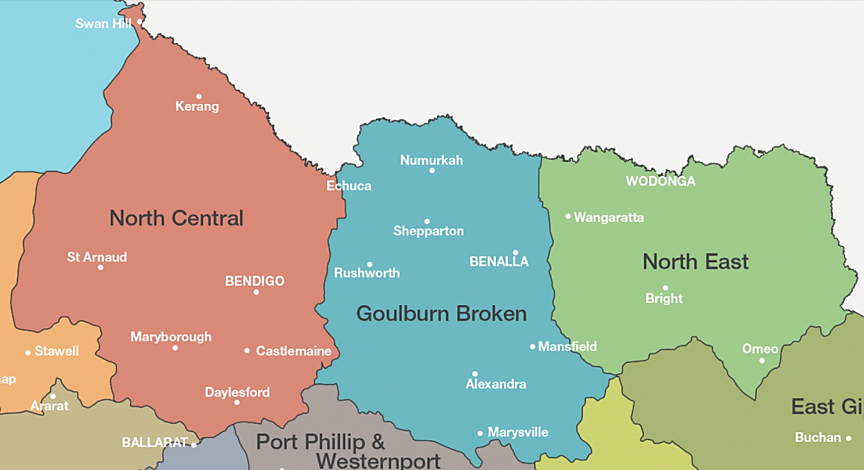

Figure 5-0: Map showing Goulburn Broken CMA and neighbouring CMA districts.
Before lodging an application with council or CMA, applicants may wish to carry out a self-assessment, which may be beneficial to resolve issues prior to lodgement. To do this, follow the process (workflow) in Section5.2 that the CMA uses to assess applications.

Workflow and application assessment
Workflow and application assessments are carried out in the following priority order, namely:
- Flood controls and requirement contained within a council planning scheme refer Figure 5-2; and
- Floodplain requirements where a council planning scheme does not contain flood overlays or floodway zones refer to Figure 5-3.
A checklist table has been provided at Appendix D that may be used to ensure that all relevant matters have been considered in assessing floodplain applications.

Verbal enquiries (telephone and counter enquiries)
The CMA may assist with direct enquiries by guiding people to publically available information (such as planning schemes online and VFD) and to the self-assessment guidelines contained on the CMA website (including this document). Where such information does not meet the needs of the applicant then the Flood Advice form is required to be completed and submitted with the prescribed fee. It is not effective to provide detailed verbal advice as:
- Relevant information must be researched and gathered;
- The information must be interpreted;
- The location must be determined beyond any reasonable doubt; and
- The written advice will contain relevant flood information together with a considered response that can be relied upon.

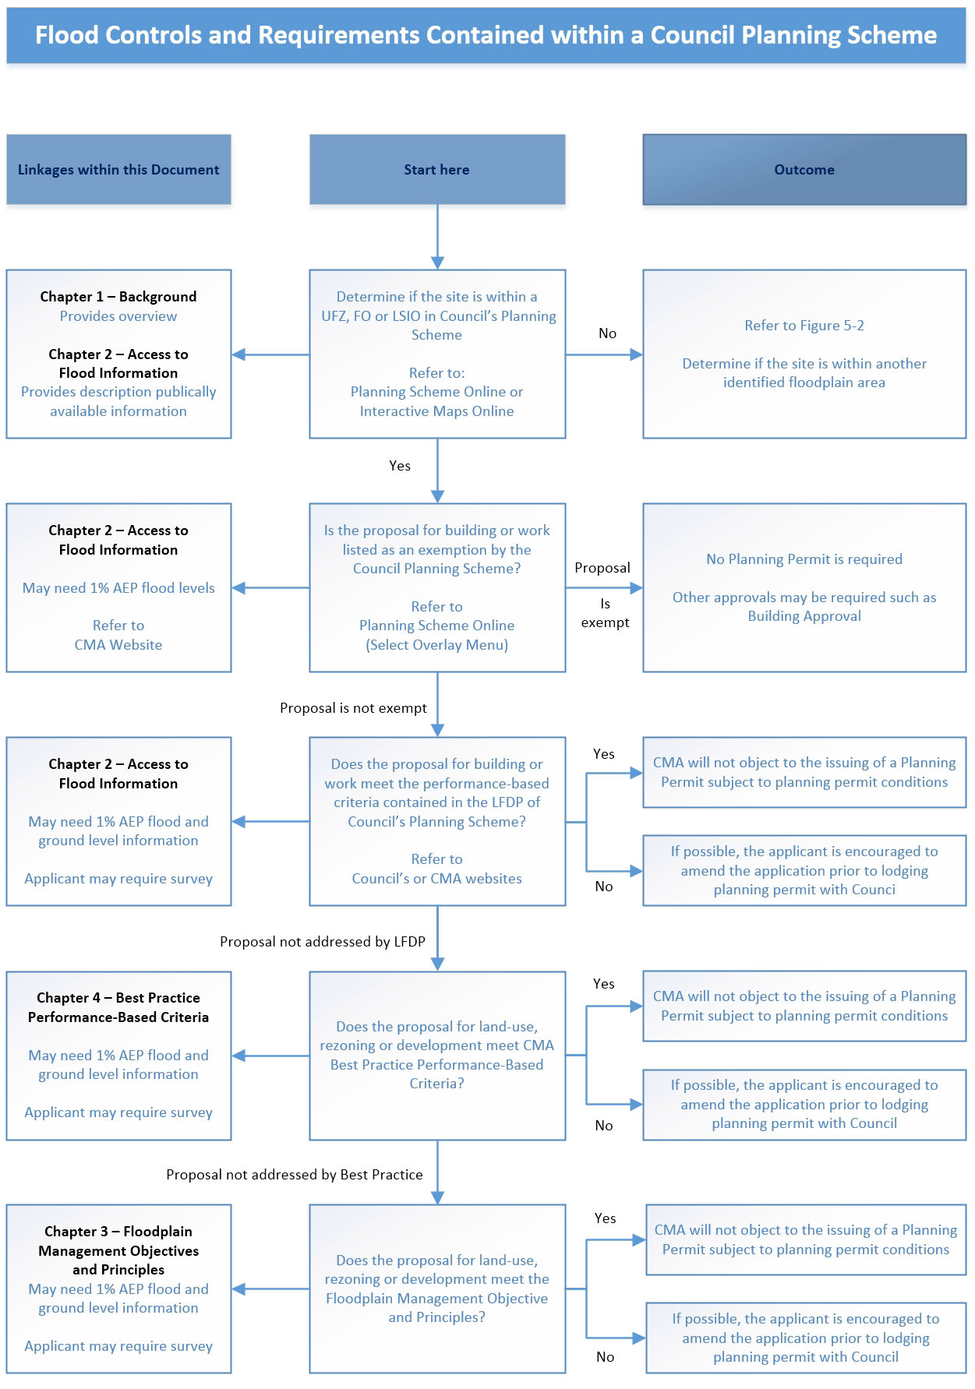
Figure 5-2: Flood controls and requirements contained in council planning schemes

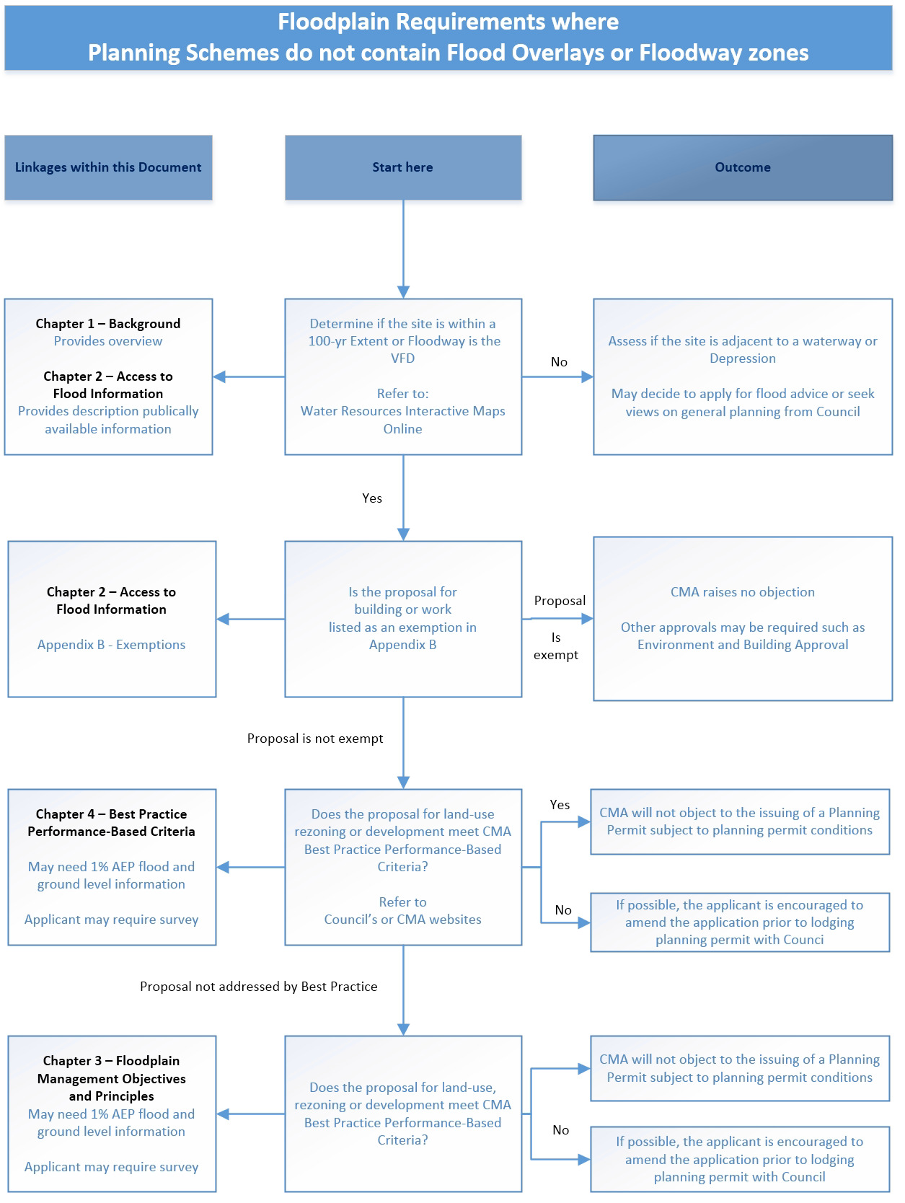
Figure 5-3: Floodplain requirements where planning schemes do contained flood overlays or floodway zones

APPENDICES

APPENDIX A: Statutory referral types, time frames, response options, restrictions and application register

Table A: Statutory referral types, time frames, response options and restrictions
Agency | Referral Type | Time Frame | Response options | Restrictions | Act
Planning Authority | Notice of a Planning Application | 14 days  (s52) | Non-specified in the Act but may as the case requires:  - Request further information  - Object  - Not object to the grant of permit,  - Recommend/request conditions  - Offer comments /advice. | Advice is not binding on Councils  A copy of the application does not have to be provided. | Planning and Environment Act 1987
Planning Authority | Referral of a Planning Application | 28 days  (s55) | - Request further information with 21 days.  - Object  - Not object to the grant of permit,  - Recommend/request conditions  - Offer comments /advice. | Advice is not binding on Councils  Limited to LSIO and FO. | Planning and Environment Act 1987
Planning Authority | Notice of Planning Scheme Amendment | 28 days min.  (s19) | - A submission may support, oppose, or seek changes to an amendment.  - A submission can, request that a State-standard provision be included in or deleted from the scheme  - The response should set out the CMAs views on the amendment, and what the CMA would like the LGA to do. | A submission must not request a change to the terms of any State-standard provision to be included in a planning scheme by the amendment. | Planning and Environment Act 1987
Planning Authority | Referral of subdivision plans | 28 days  (s8 certification of plan)  (s21 statement of compliance) | - consents to the plan; or  - requires specified alterations; or  - refuses consent.  - If the authority requires specified alterations or refuses consent, it must give written reasons to the Council http://www.austlii.edu.au/au/legis/vic/consol_act/sa1988153/s3.html - council and the applicant (s9) |  | Subdivision Act 1988
Dept of State Development Buisness and Innovation | Work Plan endorsement  (Mines/quarries) | 28 days  (s77TF) | - agree to statutory endorsement,  - agree to statutory endorsement subject to conditions, or  - object to statutory endorsement on any specified ground | no option of requesting further information | Mineral Resources (Sustainable Development) Act 1990
Dept of Environment and Primary Industries | General Crown Land Licenses  (Gravel Extraction, water storage, recreation)  Crown Frontages  Unused roads | As specified | - ensure that public land values are protected  - Recommend/request conditions  - Offer comments /advice. |  | A variety of legislation enables the licensing of Crown land for specified uses.
Rural Water Authority | Licence to take and use water (s51) | 30 days  (s51) | - consider the application; and  - advise in writing that—  - it does not object to the issue of a licence; or  - it does not object if the licence is issued subject to the conditions specified by the body; or  - it objects to the issue of the licence on any specified ground; and  - give comments on the application. | give a copy of an application under section 51 in respect of a dam, whether or not on a waterway  If a body makes no response to the Minister within 30 days after receipt of an application referred to it under section 51B, the Minister may proceed to determine the application | Water Act 1989
Rural Water Authority | Licence to construct works (s 67) | 30 days  (s67B) | - consider the application; and  - advise in writing that—  - it does not object to the issue of a licence; or  - it does not object if the licence is issued subject to the conditions specified by the body; or  - it objects to the issue of the licence on any specified ground; and  - give comments on the application. | an application under section 67 in respect of a dam, whether or not on a waterway.  If a body makes no response to the Minister within 30 days after receipt of an application referred to it under section 51B, the Minister may proceed to determine the application | Water Act 1989
Environment Protection Authority (EPA) Victoria | Works Approval (s19B) | 21 days  (s19B) | - may include any objections or  - Recommendations in relation to the application. |  | Environment Protection Act 1970

Application Register
The CMA as a referral authority under the Planning and Environment Act 1987 and Regulation 2005 is required to maintain a register with the following prescribed information:
- the name of the responsible authority that referred the application; and
- the permit application number given by the responsible authority; and
- the reference number given to the application by the referral authority (if any); and
- the date the referral authority received the application; and
- the address of the land affected by the application; and
- the proposed use, development or other matter for which the application is made; and
- the date and decision of the referral authority.
This register captures the requirements of Section 56A of the Planning and Environment Act 1987, in that the CMA must keep a register containing the prescribed information in respect of all applications referred to it under Sections 55 and 57C, which must be available at its office during office hours for any person to inspect free of charge.
The register also provides a management tool for reporting. Accordingly the register contains all referrals and enquires. All personal information is removed from the register.

Privacy
The CMA is committed to protecting personal and sensitive information collected in the course of performing its functions. The CMA is subject to the provisions of the Freedom of Information Act 1982. We also have obligations under the Information Privacy Act 2000 in respect of how we collect, use, disclose and manage personal information.

APPENDIX B: Exemption from floodplain management conditions
These exemptions do not apply for those high energy floodplain areas as described in Section 4.2.1.
The following types of buildings do not require floodplain management assessment or conditions.
- A hay shed located in a rural/farming zone;
- An upper storey extension to an existing building within the existing building footprint;
- A once-off dwelling extension where the total combined ground floor area of the extension is not greater than 20m²;
- A pergola, veranda, decking, garage, carport or domestic shed adjoining to an existing dwelling;
- An in-ground swimming pool with an open style security fencing adjacent to an existing dwelling;
- sportsground, racecourse or recreation area (with no permanent grandstand or raised viewing area), pathways and trails constructed at general natural surface elevation, playground, open picnic shelter, picnic table, drinking tap, rubbish bin, barbecue, works associated with an apiary or underground infrastructure;
- A pump shed;
- An agricultural shed (other than one used for industrial, retail or office purposes) for the storage of farm machinery, farm vehicles and workshop associated with a rural use in a farming zone with a floor area not more than 100m²;
- A mast, antenna, lighting or telecommunications tower;
Applicants should check if exemptions are listed in council’s planning scheme. This can be done using planning schemes online and selecting the overlay menu. Exemptions (if any) are contained within the schedule to the FO and LSIO.
It is prudent for applicants to seek if any other necessary approvals that council may require.

APPENDIX C: Information to be provided by the applicant
An application to construct a building, construct or carry out works or to subdivide land or to seek a planning scheme amendment, must be accompanied by plans and supporting documents that demonstrate the relevant requirements of this document have been met by the development. Refer to Section 5.2 Workflow and application assessment.
The minimum information listed below needs to be provided by the applicant in order for the CMA to adequately assess the proposed development impacts in relation to environmental values, water quality, floodplains and flood risk. Where insufficient information has been provided, the CMA will request further information to enable a full assessment of the application.
Minimum Information to be provided is as follows:
- Name, and address, telephone number and email address (if available) of landowner and applicant;
- Property description, e.g. street address, parish name, CA No, Section No, Lot No, LP or PS details;
- Purpose of application, e.g. dwelling, subdivision, earthworks, planning scheme amendment;
- Existing and proposed use of the site;
- Where the property description is not detailed, an accurate locality plan of the property, showing existing property boundaries (and proposed subdivision boundaries if proposed). This is typically either a copy of the title or a plan from Land Victoria (www.land.vic.gov.au).
- From Statutory Authorities:
- Authority Application number or Reference;
- Contact officer, address, telephone number and email address;
- Statement of the relevant section of the Act for which the referral has been made;
Where relevant, the supporting documents and plans (drawn to scale) must show the following:
- A flood risk report, which demonstrates compliance with the relevant requirements of this document.
- The boundaries and dimensions of the property.
- A regional locality plan showing the property whereabouts within the region, including roads, streams and other prominent land marks.
- The layout plan of the existing and proposed building, works or subdivision boundaries including if applicable:
- existing natural ground levels along accessways to flood free land (as indicated by the planning scheme flood overlays and zone or if not present then VFD must be checked) to Australian Height Datum, taken by a licensed surveyor. The accessway includes access along any relevant government road to the property and then to the proposed dwelling location;
- existing and proposed buildings, including floor levels to Australian Height Datum;
- existing and proposed earthworks, including finished surface levels, embankment alignments and crest levels to Australian Height Datum;
- existing and proposed fencing;
- existing and proposed drainage systems, including waterways, pipelines, drains, culverts and bridges;
- other important physical features upstream and downstream of the property that may affect flows, such as levee banks, fences and retaining walls.

APPENDIX D: Decision guidelines and fundamental principles checklist
VPPs Decision Guidelines |  | Fundamental Principles
 |  | Flood Flow | Flood Storage | Site Safety | Site Access | Flood Damage | Waterway Condition | Water Quality
SPPF  Clause 13.02-1 | Floodplain management Objective - State Planning Policy Framework  To assist the protection of:
SPPF  Clause 13.02-1 | - Life, property and community infrastructure from flood hazard. |  |  | ✓ | ✓ | ✓
SPPF  Clause 13.02-1 | - The natural flood carrying capacity of rivers, streams and floodways. | ✓
SPPF  Clause 13.02-1 | - The flood storage function of floodplains and waterways. |  | ✓
SPPF  Clause 13.02-1 | - Floodplain areas of environmental significance or of importance to river health. |  |  |  |  |  | ✓ | ✓
LPPF | Refer to each Councils Local Planning Policy Framework.
Clause 65 | 65.01 Approval of an application or plan  Before deciding on an application or approval of a plan, the responsible authority must consider, as appropriate:
Clause 65 | - The matters set out in Section 60 of the Act.
Clause 65 | - The State Planning Policy Framework and the Local Planning Policy Framework, including the Municipal Strategic Statement and local planning policies.
Clause 65 | - The purpose of the zone, overlay or other provision.
Clause 65 | - Any matter required to be considered in the zone, overlay or other provision.
Clause 65 | - The orderly planning of the area.
Clause 65 | - The effect on the amenity of the area. |  |  |  |  |  | ✓
Clause 65 | - The proximity of the land to any public land.
Clause 65 | - Factors likely to cause or contribute to land degradation, salinity or reduce water quality. |  |  |  |  |  |  | ✓
Clause 65 | - Whether the proposed development is designed to maintain or improve the quality of stormwater within and exiting the site. |  |  |  |  |  |  | ✓
Clause 65 | - The extent and character of native vegetation and the likelihood of its destruction. |  |  |  |  |  | ✓
Clause 65 | - Whether native vegetation is to be or can be protected, planted or allowed to regenerate. |  |  |  |  |  | ✓
Clause 65 | - The degree of flood, erosion or fire hazard associated with the location of the land and the use, development or management of the land so as to minimise any such hazard. | ✓ |  | ✓ | ✓ | ✓

UFZ | Before deciding on an application, in addition to the decision guidelines in Clause 65, the  responsible authority must consider, as appropriate:
UFZ | - The State Planning Policy Framework and the Local Planning Policy Framework, including the Municipal Strategic Statement and local planning policies.
UFZ | - The local floodplain development plan or flood risk report. | ✓ | ✓ | ✓ | ✓ | ✓
UFZ | - Any comments of the relevant floodplain management authority. | ✓ | ✓ | ✓ | ✓ | ✓ | ✓ | ✓
Flood Risk Report | Flood risk report  If a local floodplain development plan for the area has not been incorporated into this scheme, an application must be accompanied by a flood risk report to the satisfaction of the responsible authority. The flood risk report must consider the following, where applicable:
Flood Risk Report | - The existing use and development of the land.
Flood Risk Report | - Whether the proposed use or development could be located on flood-free land or land with a lesser flood hazard outside this zone. |  |  | ✓ | ✓ | ✓
Flood Risk Report | - The susceptibility of the development to flooding and flood damage. | ✓ | ✓ |  |  | ✓
Flood Risk Report | - The potential flood risk to life, health and safety associated with the development. |  |  | ✓ | ✓ | ✓
Flood Risk Report | Flood risk factors to consider include:
Flood Risk Report | - The frequency, duration, extent, depth and velocity of flooding of the site and accessway. |  |  | ✓ | ✓ | ✓
Flood Risk Report | - The flood warning time available. |  |  | ✓ | ✓ | ✓
Flood Risk Report | - The danger to the occupants of the development, other floodplain residents and emergency personnel if the site or accessway is flooded. |  |  | ✓ | ✓
Flood Risk Report | - The effect of the development on redirecting or obstructing floodwater, stormwater or drainage water and the effect of the development on reducing flood storage and increasing flood levels and flow velocities. | ✓ | ✓
Flood Risk Report | - The effects of the development on environmental values such as natural habitat, stream stability, erosion, water quality and sites of scientific significance. |  |  |  |  |  | ✓ | ✓

FO | Before deciding on an application, in addition to the decision guidelines in Clause 65, the responsible authority must consider, as appropriate:
FO | - The State Planning Policy Framework and the Local Planning Policy Framework, including the Municipal Strategic Statement and local planning policies. | ✓ | ✓ | ✓ | ✓ | ✓ | ✓ | ✓
FO | - The local floodplain development plan or flood risk report. | ✓ | ✓ | ✓ | ✓ | ✓ | ✓ | ✓
FO | - Any comments of the relevant floodplain management authority. | ✓ | ✓ | ✓ | ✓ | ✓ | ✓ | ✓
FO | - The Victorian River Health Strategy (2002) and any relevant regional river health strategy and associated wetland plan. |  |  |  |  |  | ✓ | ✓
LSIO | Before deciding on an application, in addition to the decision guidelines in Clause 65, the  responsible authority must consider, as appropriate:
LSIO | - The State Planning Policy Framework and the Local Planning Policy Framework, including the Municipal Strategic Statement and local planning policies. | ✓ | ✓ | ✓ | ✓ | ✓
LSIO | - Any local floodplain development plan.
LSIO | - Any comments from the relevant floodplain management authority. | ✓ | ✓ | ✓ | ✓ | ✓
LSIO | - The existing use and development of the land. |  |  | ✓ | ✓ | ✓
LSIO | - Whether the proposed use or development could be located on flood-free land or land with a lesser flood hazard outside this overlay. |  |  | ✓ | ✓ | ✓
LSIO | - The susceptibility of the development to flooding and flood damage. |  |  | ✓ |  | ✓
LSIO | - The potential flood risk to life, health and safety associated with the development. |  |  | ✓ | ✓
LSIO | Flood risk factors to consider include:
LSIO | - The frequency, duration, extent, depth and velocity of flooding of the site and accessway. |  |  | ✓ | ✓ | ✓
LSIO | - The flood warning time available. |  |  | ✓ | ✓ | ✓
LSIO | - The danger to the occupants of the development, other floodplain residents and emergency personnel if the site or accessway is flooded. |  |  | ✓ | ✓
LSIO | - The effect of the development on redirecting or obstructing floodwater, stormwater or drainage water and the effect of the development on reducing flood storage and increasing flood levels and flow velocities. | ✓ | ✓
LSIO | - The effect of the development on river health values including wetlands, natural habitat, stream stability, erosion, environmental flows, water quality and sites of scientific significance. |  |  |  |  |  | ✓ | ✓

SBO | The CMA has no SBOs at this time.
Practice Note | A council or floodplain management authority should consider the following decision guidelines when deciding or commenting on an application:
Practice Note | - A development must be consistent with:
Practice Note | - the SPPF (clause 13.02) | ✓ | ✓ | ✓ | ✓ | ✓ | ✓ | ✓
Practice Note | - any flood-related statements made in the MSS (clause 21) and local planning policies (clause 22) of the planning scheme
Practice Note | - any flood-related guidelines incorporated in the planning scheme
Practice Note | - any regional catchment strategy or floodplain management strategy adopted by the CMA
Practice Note | - any local floodplain development plan adopted by a council
Practice Note | - any other development guidelines agreed to by the council and the floodplain management authority.
Practice Note | - The potential impact of an extreme event larger than the 100-year ARI flood on life, health, safety and damage. | ✓ | ✓ | ✓ | ✓ | ✓
Practice Note | - Emergency facilities should be located above the 100-year ARI flood level, and preferably above the PMF level.
Practice Note | - The possibility of relocating that development to land which is flood-free or which has a lesser risk. |  |  | ✓ | ✓ | ✓
Practice Note | - Residential, commercial and industrial buildings are not generally an appropriate development on floodway land in view of their potential for flood hazard and for obstruction of flood flows. | ✓ | ✓ | ✓ | ✓ | ✓ | ✓ | ✓
Practice Note | - Significant earthworks, such as levee banks, channel banks and raised roads are not appropriate on floodway land in view of their potential for obstruction of flood flows. | ✓ | ✓
Practice Note | - The incremental long-term effects of developments. While a single development may not cause a significant change, the cumulative effect of several similar developments may be substantial. | ✓ | ✓ | ✓ | ✓ | ✓ | ✓ | ✓
Practice Note | - The design of buildings should adopt flood-proofing measures that minimise the physical effects of flooding on the building structure and its contents. |  |  |  |  | ✓
Practice Note | - Activities that generate or store significant quantities of nutrients or noxious or hazardous materials should not be located on land subject to inundation; for example, sewage treatment and pumping plants, intensive animal industries, sanitary landfill depots and food-processing plants. |  |  |  |  |  | ✓ | ✓
Practice Note | - A development should be refused if it is likely to cause an unacceptable increase in flood risk in the following situations:
Practice Note | - it is likely to result in danger to the life, health and safety of the occupants due to flooding of the site |  |  | ✓
Practice Note | - it relies on low-level access to and from the site |  |  |  | ✓
Practice Note | - it is likely to increase the burden on emergency services and the risk to emergency personnel |  |  | ✓ | ✓ | ✓
Practice Note | - it is likely to increase the amount of flood damage to public or private assets
Practice Note | - it is likely to raise flood levels or flow velocities to the detriment of other properties. Potentially adverse effects on upstream and downstream areas must be identified and addressed. Development should not transfer flooding problems from one location to another | ✓
Practice Note | - it is likely to obstruct flood flows or reduce natural flood storage. The capacity of land subject to inundation to convey and store floodwater must be maintained | ✓ | ✓
Practice Note | - it is likely to be detrimental to natural habitats, waterway stability, water quality or sites of significance |  |  |  |  |  | ✓ | ✓
Practice Note | - if any subdivision, development or redevelopment is likely to increase the number of buildings located in a floodway area. |  |  |  |  | ✓

Also the Special Building Overlay (SBO) may be used to define overland flow paths. Currently, SBO has not been used in the CMA.
Taken from Section 4.1.2, Limits of Afflux, Flood Plain Management in Victoria (Water Resources Council of Victoria The, 1978).

